KAZAKH NATIONAL UNIVERSITY NAMED AFTER AL-FARABI

FACULTY OF CHEMISTRY AND CHEMICAL TECHNOLOGY
Department of physical chemistry, catalysis and petrochemistry

Methodical instructions for laboratory work
Study of the kinetics of the oxidation reaction of thiourea with hexacyanoferrate (III)
in an alkaline environment

ON THE COURSE “PHYSICAL CHEMISTRY”

Approved at the meeting of the department of physical chemistry, catalysis and petrochemistry
dated “ ___ ” _____ 202___, protocol No. ___

Head of the department ________Ye.A. Aubakirov

.

1. AIM OF THE WORK

The aim of this work is to study the kinetics of the oxidation reaction of thiourea with hexacyanoferrate (III) in an alkaline medium. Determination of the average reaction rate constant by graphical and analytical methods.

2. THEORETICAL POSITIONS

Chemical kinetics considers the rate of chemical reactions and the parameters on which they depend. The most important parameters are concentration, temperature, pressure.
The reaction rate in general is determined by the change in the amount of substance per unit of time, per unit of reaction space:

where R is a reaction space;
n is the number of moles of a given component at time t.
For homogeneous reactions, R is the volume and, under the condition of its constancy, expression (1) is simplified:

The reaction rate is determined by the change in the concentration of the reactant per unit of time.
For heterogeneous reactions, R is the specific surface (A) and expression (1) for such reactions has the form:

The reaction rate is always positive, but the signs (+) or (-) are used depending on the change in the concentration of which substances are being determined. If the calculation is carried out according to the change in the concentration of the starting substances, then the sign will be negative (-), or if the rate of this process is determined by the change in the reaction products, it will be positive (+).
The reaction rate is expressed as the derivative of the concentration with respect to time for any substance involved in the reaction. The initial substances are consumed, and the reaction products are formed in equivalent amounts in accordance with their stoichiometric coefficients; therefore, when determining the reaction rate there is no need to monitor the change in the concentration of all interacting substances. In general, the reaction rate that proceeds according to the equation:

can be adequately represented by several equations:

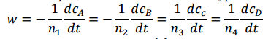

where n₁, n₂, n₃, n₄ are stoichiometric coefficients.
The dependence of the rate on the concentration of the initial substances is expressed by the law of mass action:

where k is the rate constant of the reaction, n₁ and n₂ are numbers indicating the particular order of the reaction for components A and B, respectively. The overall reaction order is:
n= n₁ +n₂

Dependence (4) is called the basic postulate of chemical kinetics: the reaction rate at each moment of time is proportional to the product of the concentration of the reacting substances raised to a certain power.

An important characteristic in chemical kinetics is the rate constant. Its physical meaning is that, provided that the concentration of reactants is equal to unity (C_{A} = C_{B} = 1) for homogeneous reactions, the rate constant is equal to the reaction rate W = ka for heterogeneous reactions W ≠ k. The dimension of the rate constant is determined by the kinetic equation by which it is calculated depending on the order of the reaction. In general, this can be represented as follows:

{k}=(conc) ^{n+1 .} (time)⁻¹

where n₁ is the order of the reaction.
A distinction is made between average and true reaction rates. The average reaction rate ($\overline{W}$) for a given period of time is the ratio of the change in the concentration of the reagent (initial substance or the reaction product) to the time, and during which this change occurred:
A distinction is made between average and true reaction rates. The average reaction rate is found by the following formula:

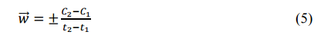

The true reaction rate (w) at a given time can be expressed as an infinitesimal change in the concentration of a reactant over an infinitesimal time interval, i.e. as the derivative of concentration with respect to time:

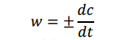

For the reaction of different orders, the differential and integral forms of kinetic equations will have different dependencies. For the first-order reaction: A→B, w = kC_{A}, differential equations are:

-dC_{A}/dt =KC_{A} or dx/dt =K(a-x)

where х is a quantity of a substance, which has interacted by the time t;
a is the initial concentration of the substance.
Integral forms of the kinetic equation:

K=1/t ∙ ln C₀/C = 1/t ∙ ln a/(a-x)

where C₀ is an initial concentration;
С is a concentration of the substance by the time t.

An important characteristic in kinetics is the half-life or half-transformation period – the time during which the half amount of matter reacts. For first-order reactions the half-life t_{1/2} is determined by the equation:

t_{1/2} = ln2/K = 0,693/K

For second-order reactions (A + B → C + D), if the initial concentrations of the reactants are the same, w = KC, the differential forms of the kinetic equation are the following:

-dC_{A}/dt =KC_{A}² or dx/dt =K(a-x)²

And the integral forms of the kinetic equation are:

K=1/t (1/C - 1/C₀) = 1/t ∙ x/a(a-x) or t_{1/2} = 1/KC₀

For a second-order reaction A+B → C+D, if the initial concentrations of the reactants are not the same (C_{A} ≠ C_{B}), w =${kC}_{A} C_{B}$, then the differential equations take the following form:

-dC_{A}/dt = KC_{A} C_{B} or dx/dt = K(a-x)(b-x)

where a and b are initial concentrations of reactants A and B.

The integral form of the kinetic equation will be:

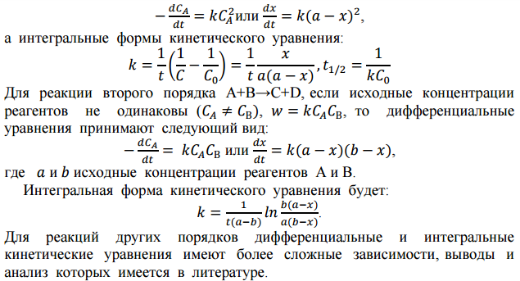

For reactions of other orders, differential and integral kinetic equations have more complex dependencies, the conclusions and analysis of which are available in the literature.
An important characteristic of chemical reactions is molecularity. The molecularity of a reaction is determined by the number of particles involved in one elementary act of chemical transformation. At the same time, the number of molecules of the substances formed does not matter. There are monomolecular, bimolecular and trimolecular reactions. The order of the reaction and the molecularity may coincide for the simplest homogeneous reactions, and most often they are different. The reason for this is the course of the reaction by a complex mechanism. In addition, the cause of the discrepancy may be a significant excess of one of the reactants in the reaction mixture. Then the concentration of this reactant remains almost constant during the reaction, and the order is less than that determined by the stoichiometric equation.
Reaction order and molecularity differ in that:
- the order of the reaction can take any values (negative, positive, fractional numbers and zero), and the molecularity is one, two and three;
- order is an experimental quantity and refers to the reaction as a whole, while molecularity refers only to an elementary act of chemical transformation and is a theoretical quantity.
The rate constant is the most important of all the kinetic characteristics of chemical reactions. The larger the rate constant, the greater the speed.
For reactions of the n^{th} order (except for the first), with equal concentrations of all initial substances, the rate constant is expressed by the equation:

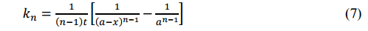

The effect of temperature on the rate of the chemical reaction

The rate of chemical reactions usually increases with the increase in temperature. The dependence of the reaction rate on temperature is approximately described by the van't Hoff rule:

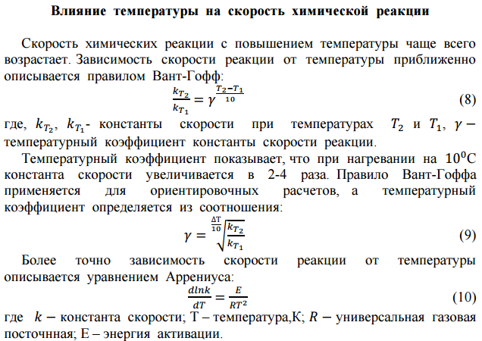

where, k_{T2}, k_{T1} are rate constants at temperatures T₂ and T₁;
γ is the temperature coefficient of the rate constant of the reaction.
The temperature coefficient shows that during heating for every 10 ºC, the rate constant increases by 2-4 times. The van't Hoff rule is used for approximate calculations, and the temperature coefficient is determined from the ratio:

More precisely, the dependence of the reaction rate on temperature is described by the Arrhenius equation:

where k is the rate constant;
Т is the temperature, K;
R is the universal gas constant;
Е is the activation energy.
It is possible to compare the rate constants of chemical reactions only if the reaction order for the processes under study is the same.
Methods of determination of the reaction order are divided into two large groups: integral and differential, which are described in detail in all textbooks on physical chemistry /2-4/
After integration, equation (10) takes the form:

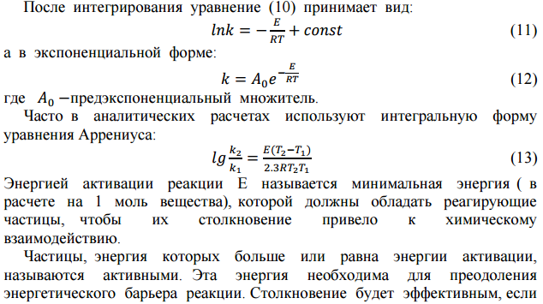

And in exponential form:

where $А_{0}$ is a pre-exponential multiplier.
Often in analytical calculations, the integral form of the Arrhenius equation is used:

The activation energy of reaction E is the minimum energy (per 1 mol of matter) that the reacting particles must possess in order for their collision to lead to chemical interaction.
Particles whose energy is greater than or equal to the activation energy are called active. This energy is necessary to overcome the energy barrier of the reaction. A collision will be effective if the total amount of energy of the colliding particles is equal to or greater than the activation energy characteristic of a given reaction. Schematically, the formation of active particles can be represented as follows:

А + А + Е → А* + А*,

where А* are active particles.
Activation energy is a potential barrier that must be overcome by particles whose energy is greater than or equal to E (active particles).
A₀ – pre-exponential multiplier – according to the theory of active collisions, is the collision factor (Z₀), which is related to the total number of double collisions (Z) in 1 cm³ in 1s. The values of Z₀ and Z can be determined on the basis of molecular kinetic theory /5/. Therefore, by replacing A with Z₀, the rate constant can be calculated from the equation:

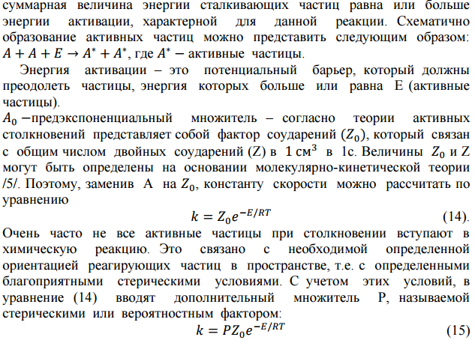

Very often, not all active particles enter into a chemical reaction upon collision. This is due to the necessary specific orientation of the reacting particles in space, i.e. with certain favorable steric conditions. Taking into account these conditions, an additional factor P, called the steric or probabilistic factor, is introduced into equation (14):

This equation reveals the physical meaning of A₀. Since A₀ = PZ₀, then A₀ is a function of the total number of collisions and the steric factor.
Thus, the activation energy characterizes the dependence of the reaction rate on temperature. The larger E, the faster the reaction rate increases with increasing temperature, and the lower the activation energy, the greater the reaction rate constant, because a large proportion of particles can overcome the energy barrier.

Methods of activation energy calculation

In research practice, two methods are usually used to determine the activation energy:
- A calculation method that is based on the application of a certain integral form of the Arrhenius equation:

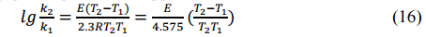

Equation (16) can be used to calculate the activation energy from the rate constants at two temperatures
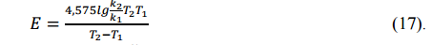

- Graphical method, which is based on the use of the indefinite integral form of the Arrhenius equation:

lnk=lnA₀ - E/RT

Thus, the most important kinetic characteristics of a chemical reaction are the rate, rate constant, reaction order, activation energy, and pre-exponential factor. Therefore, the task of chemical kinetics is to determine these parameters by various physicochemical methods. The most common methods are based on the dependence of the physical properties of a mixture on its composition, such as spectrophotometry, spectroscopy, mass spectrometry, and chromatography. The use of these methods is based on the preliminary obtaining of calibration curves of the dependence of the physical property on the concentration, and then determining the concentration of the reactants.
The spectrophotometric method is applicable in those cases when the initial substance or one of the reaction products absorbs in a given region of the spectrum (colored), and the rest of the substances involved in the reaction are colorless.
Therefore, to calculate the reaction rate constant, it is necessary to measure the optical density of the solution and its change with time.
A chemistry expert in his professional activity will have to work on a photo colorimeter. This practical work assumes familiarization with the device and the use of a photo colorimeter to determine the kinetic parameters of the oxidation reaction of thiourea with hexacyanoferrate (III) (red blood salt) in an alkaline solution.
The oxidation reaction of thiourea proceeds according to the equation:

NH₂CSNH₂+10OH⁻+8[Fe(CN)₆]³⁻ = NH₂CONH₂+SO₄²⁻+8[Fe(CN)₆]⁴⁻+5H₂O (18)

and has the first order in thiourea, hexacyanoferrate (III) and hydroxyl ions, and the overall reaction order is 3. The calculation of the rate constant of reaction (18) will depend on the conditions of its implementation. There are three options.

FIRST OPTION:

а) The concentrations of all three substances are comparable in magnitude and not equal to each other, then the reaction rate is determined by the equation:

w = k. C_{A} .C_{B}. C_{C} (19)

b) The concentrations of all three substances are equal to each other, in this case:

w = k. C³ (20)

SECONDS OPTION:

- The concentration of one of the three substances is in excess, and then its change can be neglected. The order of the reaction is reduced by one and the rate of the process is given by the equation (12):

w = k. C_{A} .C_{B} (21)

- If C_{A} = C_{B}, then:

w = k. C_{A}² (22)

THIRD OPTION:

The concentrations of two substances are in great excess, then

w = k. C_{A}

i.e., the reaction order, in this case, is equal to one.
Usually, the kinetics of this reaction is studied in a strongly alkaline solution (pH=11) and 10-15-fold excess of thiourea compared to the concentration of red blood salt. Then the changes in the concentrations of OH⁻ and NH₂CSNH⁻ can be neglected, assuming them to be constant during the experiment. The speed of the process will be determined by the equation:

w = k.[Fe(CN)₆³⁻].

Therefore, the rate constant of this reaction can be calculated from the equation

(23)

3. OPERATING PROCEDURE

EQUIPMENT AND MATERIALS:

0.025 M Na₂CO₃ solution, 0.025 M NaHCO₃ solution, 0.02 M K₃[Fe(CN)₆] solution, 0.02 M thiourea solution, thermostat, photoelectric colorimeter.

ORDER OF WORK PERFORMANCE:

(the third option).
- Prepare a buffer mixture (a mixture of equal volumes of 0.025 M Na₂CO₃ and 0.025 M NaHCO₃) that maintains pH=11.
2. Prepare a series of standard (reference) solutions of K₃[Fe(CN)₆] in 50 ml volumetric flasks.
Prepare standard solutions of the following concentrations (mol/l):
1.10⁻⁴, 2.10⁻⁴, 3.10⁻⁴, 4.10⁻⁴, 5.10⁻⁴, 6.10⁻⁴, 7.10⁻⁴, 8.10⁻⁴, 9.10⁻⁴.
These solutions are prepared by diluting a 0.02 M solution of K₃[Fe(CN)₆] with a carbonate-bicarbonate mixture.
Record the results of measurements of the optical density of standard solutions in Table 1 according to the sample. Light filter is 400 nm. Cuvette size is 10 mm.

Table 1

Table for recording experimental data

Number of the flask | Concentration of K₃[Fe(CN)₆], mol/l | The volume of the working solution to obtain the standard solution | Optical density, А
1
2
3
4

Prepare a volumetric flask (50 ml) containing 1 to 4 ml of 0.02 M K₃[Fe(CN)₆] in the buffer mixture; a flask containing from 10 to 40 ml of a 0.02 M solution of thiourea in the buffer mixture; flask with carbonate-bicarbonate buffer solution.
The concentration of thiourea in the reaction mixture should be 10-15 times higher than the concentration of K₃[Fe(CN)₆]. At a high concentration of the recoverable substance, the solution becomes cloudy due to the precipitation of sulfur. The lower limit of the concentration of hexacyanoferrate (III) is determined by the sensitivity of the photoelectric colorimeter. If the concentration of hexacyanoferrate (III) in the solution exceeds 6.10⁻³ mol/l, the samples for colorimetry should be diluted.
Place three flasks in a thermostat and hold for 5-10 minutes at a temperature of 40-50 ºC, after which the thiourea solution is poured into a flask with a solution of K₃[Fe(CN)₆], marking the moment of draining the solution as the time of the start of the reaction. Bring the volume of the solution in the volumetric flask up to the mark with the buffer mixture.
During the entire experiment, the flask with the reaction mixture was kept in a thermostat. The concentration of hexacyanoferrate (III) is determined by optical density using a calibration graph. Take the first sample 5 min after the start of the reaction, the second one 10 min after, then depending on the rate of change in the optical density of the solution. The volume of samples is determined by the dimensions of the selected cuvette.

4. RESULTS PROCESSING

Record the obtained results in Table 2 according to the sample.
Experiment temperature, 40-50 ºC; initial concentration of K₃[Fe(CN)₆], mol/l; initial concentration of thiourea, mol/l.

Table 2

Table for recording the calculated data

Time of the measurement | Time from the start of the reaction, min | А | Concentration K₃[Fe(CN)₆], mol/l | С₀/С | К, min⁻¹

Based on the obtained data, determine the reaction rate constant by two methods:
a) calculation method according to the equation

b) graphical method.
It is necessary to plot the dependency lnC = f(x). By the value of tgα = - k the rate constant of the reaction is determined.
Compare results and draw conclusions.
Since the reaction under study is considered as a first-order reaction, similar calculations should be carried out using the values of the initial and current optical density of solutions.
Explain the possibility of replacing the concentration with the optical density of solutions.

5. SAFETY PRECAUTIONS

In the process of work performance, it is prohibited to:
1. Turn the equipment on and off without the teacher's permission.
2. Leave the equipment, which is energized, unattended.
3. Work with ungrounded equipment.
When performing laboratory work student must:
• work in a lab coat, if necessary, use personal protective equipment;
• work carefully, keep cleanliness;
• drain waste solutions into drain containers specially designed for this purpose;
• handle chemical glassware, reagents, equipment with care;
• perform the work in the described sequence.
- ReQUIREMENTS FOR THE REPORT

The report should contain the following sections:
- Aim of the work.
- Intermediate and final results of experiments.
- Results processing calculations.
- Conclusion based on the results of experiments and calculations.
- The work must be signed by the student and teacher.

- control questions

- What is the rate of a chemical reaction?
- What is the difference between molecularity and reaction order?
- What are the methods for determination of the reaction order?
- What is the rate constant, its physical meaning?
- Explain the physical meaning of the activation energy.
- What are the methods for determination of the activation energy?

8. RECOMMENDED LITERATURE

- Киреев В.А. Курс физической химии, М.:Химия, 1975 г., 775 с.
- Краснов К.С. Физическая химия, М: Высшая школа, 1975 г., 319 с.
- Стромберг А.Г., Семченко Д.П. Физическая химия, 1999 г., 527 с.
- Горбачев С.В. Практикум по физической химии, 1974 г., С. 388-391
- Симиохин И.В., Страхов Б.В., Осипов А.И. Кинетика химических реакций, М: МГУ, 1995 г., 347 с.

